H.T No
Regulations:
A19

Sreenidhi Institute of Science and Technology
(An Autonomous Institution)
Code No: 7R103 Date: 26-Oct-2021 (FN)

M.Tech I-Year I-Semester External Examination, Oct/Nov - 2021 (Supplementary)
ADVANCED COMPUTER NETWORKS (CNIS)

Time: 3 Hours Max.Marks:70

Note: a) No additional answer sheets will be provided.
b) All sub-parts of a question must be answered at one place only, otherwise it will not be valued.
c) Missing data can be assumed suitably.

ANSWER ANY 5 OUT OF 8 QUESTIONS. EACH QUESTION CARRIES 14 MARKS.

Bloom's Cognitive Levels of Learning (BCLL)

Remember | L1 | Apply | L3 | Evaluate | L5
Understand | L2 | Analyze | L4 | Create | L6

 |  |  | BCLL | CO(s) | Marks
1. | a) | Compare Transmission delay with Propagation delay of switched Networks in detail. | L5 | CO1 | [7M]
 | b) | Discuss about the Internet Protocol (IP) addressing scheme. | L2 | CO1 | [7M]
2. | a) | Discuss about the Cyclic Redundancy Check (CRC) technique of Error Detection. | L3 | CO2 | [7M]
 | b) | Appraise briefly about Channel partitioning protocols. | L4 | CO2 | [7M]
3. | a) | Determine the least-cost path from node A to node B in the figure below using Bellman-Ford algorithm:  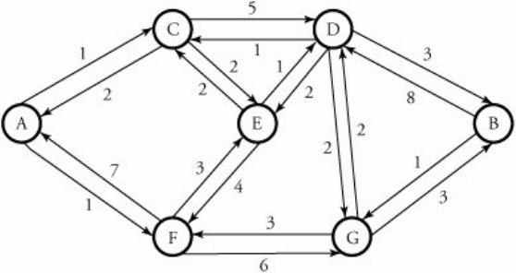 | L4 | CO3 | [7M]
 | b) | Explain about Random early detection (RED) and its setup at routers. | L3 | CO3 | [7M]
4. | a) | Discuss about the various services provided by Domain Name System (DNS). | L3 | CO4 | [7M]
 | b) | Explain about TCP segment in Transmission Control Protocol (TCP)? | L2 | CO4 | [7M]
5. | a) | Compile the steps in Distributed Coordination Function (DCF) Algorithm of 802.11 Mac Layer. | L6 | CO5 | [7M]
 | b) | Discuss about Clustering in Wireless sensor networks. | L3 | CO5 | [7M]
6. | a) | Explain the process of tunneling in point-to-point protocol used in VPN. | L3 | CO6 | [7M]
 | b) | Explain Session Initiation protocol of VoIP in detail. | L2 | CO6 | [7M]
7. | a) | Discuss about Packet Loss in networks. | L2 | CO1 | [5M]
 | b) | Write briefly about Carrier Sense Multiple Access with Collision detection CSMA/CD. | L3 | CO2 | [5M]
 | c) | Explain briefly about assigning addresses to Hosts and routers in Network layer routing? | L4 | CO3 | [4M]
8. | a) | What are the advantages of IPv6 over IPv4? | L5 | CO4 | [5M]
 | b) | Write briefly about IEEE 802.11 Physical layer. | L2 | CO5 | [5M]
 | c) | Discuss about security in VPNs. | L2 | CO6 | [4M]
-- 00 -- 00 –

